Chapter 10, Problem 28.

In the circuit of Fig. 10.76, determine the mesh currents i₁ and i₂. Let v_{i} = 10 cos4t V and v₂ = 20 cos(4t – 30°) V.

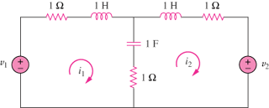

Figure 10.76
For Prob. 10.28.

